Core Concept of Git and Github

Comparison between Github and Bitbucket

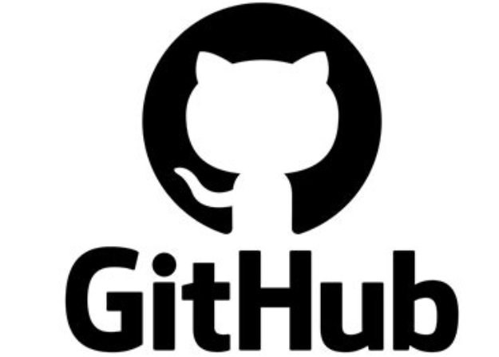

1. **What is Git? Describe the core features of Git and its role in version control.**

**Git Introduction:**

**Git** is an open-source distributed version control system created in 2005 by Linus Torvalds. It tracks changes in files, mainly source code, allowing multiple developers to collaborate simultaneously without overwriting each other’s work. Git maintains a complete history of all changes, making project development organized and secure.

**Core Features:**

* **Distributed System:** Every developer has a full copy of the repository locally, enabling work without internet access and easy collaboration.
* **Version Tracking:** Each change is saved as a commit, preserving the entire project history for easy review and recovery.
* **Branching and Merging:** Developers can create independent branches to work on features separately and merge them back safely.
* **Staging Area:** A preparation zone where changes are reviewed and selected before committing, ensuring precise updates.
* **Data Integrity:** Uses SHA-1 hashing to uniquely identify files and commits, securing the project’s history from corruption.

**2. What is GitHub? How does GitHub enhance the use of Git in collaboration and project management?**

**GitHub** is a cloud-based platform that hosts Git repositories, allowing developers to store, share, and manage projects remotely. It provides a user-friendly interface to track code changes and project history.

**Enhancements for Collaboration and Management:**

* **Collaboration:** Supports branching, pull requests, and code reviews, enabling teams to propose, discuss, and approve changes safely.
* **Project Management:** Offers tools like issues and project boards to track bugs, assign tasks, and organize work efficiently.
* **Additional Benefits:** Provides secure cloud storage, access controls, and fosters a large developer community for global collaboration.

**3. Compare and contrast GitHub and Bitbucket.**

Both GitHub and Bitbucket are cloud platforms for hosting Git repositories, but they serve different user needs.

* **Features:** GitHub is favored for open-source projects and community collaboration. Bitbucket offers strong private repository support and built-in CI/CD through Bitbucket Pipelines.
* **User Interface:** GitHub has a clean, intuitive design popular among millions of developers. Bitbucket integrates closely with Atlassian tools but has a more technical UI.
* **Integrations:** GitHub supports many third-party tools and GitHub Actions for automation. Bitbucket excels with Atlassian product integration like Jira and Confluence, aiding project tracking and documentation.

**4. How would you initialize a Git repository in your current project directory? Write down the command and explain its purpose.**

* **Command:**
* git init
* **Purpose:**  
  This command creates a local Git repository by initializing a .git folder that stores version control data. It enables tracking of all changes and prepares the project for collaboration and version management.
* **Summary:**  
  git init sets up version control locally, enabling change tracking and collaboration from the start of a project.

**5. After making changes to a file, how would you add it to the Git staging area? Provide the relevant command and explain what happens when a file is staged.**

* **Command:**
* git add <filename>
* **Explanation:**  
  Adding files to the staging area prepares selected changes for the next commit. This selective process helps maintain clear, intentional updates in the project history.
* **Summary:**  
  git add moves changes to the staging area, allowing controlled and precise commits.

**6. Once a file has been staged, how would you commit the changes? Write the command and describe the significance of the commit message.**

* **Command:**
* git commit -m "Descriptive message"
* **Significance:**  
  The commit saves staged changes permanently with a message explaining the update’s purpose. Clear messages improve collaboration, traceability, and future maintenance.
* **Summary:**  
  git commit finalizes changes with an explanatory message, creating a meaningful project history.
* **7. How can you check the status of your repository, and why is this step important? Include the command in your answer.**
* **Command:**
* git status
* **Importance:**  
  This command shows the current state of files, helping developers verify what’s changed, staged, or untracked, preventing mistakes.
* **Summary:**  
  git status provides a snapshot of changes, ensuring clarity and accuracy before committing.

**8. Explain the process of creating a new branch in Git. What is the purpose of branching in version control? Provide the command to create a branch.**

* **Command:**
* git branch <branch-name>
* **Purpose:**  
  Branches isolate work on features or fixes, allowing parallel development without affecting the main codebase, reducing risk and improving workflow.
* **Summary:**  
  Branching creates separate workstreams, enabling safe and organized development.

**9. How do you switch to a different branch in Git? Explain the use case for switching branches. Provide the command you would use.**

* **Command:**
* git checkout <branch-name>
* **Use Case:**  
  Switching branches lets developers move between tasks or contexts, like testing new features or fixing bugs on different branches.
* **Summary:**  
  git checkout changes the working context to different branches for flexible multitasking.

**10. Describe the process of merging one branch into another. Why is merging important in collaboration? Provide the command used to merge branches.**

* **Command:**
* git merge <branch-name>
* **Importance:**  
  Merging combines changes from multiple branches into one, consolidating parallel work and maintaining project continuity in team environments.
* **Summary:**  
  Merging integrates different development streams, essential for collaborative progress.

**11. How would you push your local changes to a remote repository on GitHub? Provide the command and explain what happens when you push changes.**

* **Command:**
* git push origin <branch-name>
* **Explanation:**  
  It uploads local commits to the remote repository on GitHub, making your work available to others and backing it up in the cloud.
* **Summary:**  
  git push shares local updates with remote repositories, enabling team collaboration.

**12. After pushing changes, how would you fetch and integrate changes from the remote repository? Provide the command and explain its function.**

* **Explanation:**  
  The git pull command is used to fetch the latest changes from a remote repository and automatically merge them into your current local branch. This keeps your local copy up to date with changes made by other team members, preventing conflicts and ensuring that everyone is working on the most recent version of the project. Essentially, it combines two steps — fetching new data and merging it — into a single operation.
* **Summary:**  
  git pull synchronizes your local repository with remote updates, maintaining collaboration and minimizing conflicts.